**Documentation: CryptoSoft**

**1. Summary**

CryptoSoft is a library and console application for encrypting and decrypting files using the XOR method. This documentation explains how it works, how to integrate it as a DLL in a project, and how to use it as a stand-alone application.

**2. Introducing CryptoSoft**

CryptoSoft offers a simple, fast XOR encryption method, based on an encryption key passed as a parameter. Its implementation is minimalist, guaranteeing compatibility with projects requiring fast file encryption.

Key features:

- File encryption and decryption via XOR

- DLL-based for integration into existing projects

- Can be used as a stand-alone console application

- Simple operation with two parameters: file to be encrypted and key

**3. Technical explanation**

CryptoSoft is based on the XOR algorithm, a simple, fast, yet reversible encryption using the same key. The program supports:

**a) Verification of file existence**

Before performing encryption, the application checks whether the file exists, otherwise an error message is displayed.

**b) Transformation files**

- The file is read in bytes.

- It is then processed with the XOR algorithm, applying the key supplied.

- Once transformed, the file is overwritten with the new encrypted version.

- Execution time is measured with a stopwatch.

**c) Code structure**

The code is based on a main FileManager class, which provides the TransformFile() method for encryption.

**Explanation of class:**

- Checks if files exist

- Loads file contents into memory

- Applies XOR encryption with the supplied key

- Writes the encrypted or decrypted file to disk

- Returns encryption execution time

**

**Program explanation:**

- Retrieves the file path and encryption key passed as arguments.

- Creates an instance of FileManager.

- Executes file encryption/decryption.

- Returns execution time or error code if a problem occurs.

**4. Integration as DLL**

**a) DLL creation**

CryptoSoft can be compiled into a library (DLL) for integration into a project. Here are the steps:

1. Create a “Class library (.NET 8)” project

2. Add the FileManager class to the FileManager.cs file

3. Compile the project and retrieve CryptoSoft.dll from bin/Debug/net8.0

**b) Using the DLL in a C# project**

Add the DLL as a reference in Visual Studio:

1. Right-click on the .sln project → Add reference

2. Select CryptoSoft.dll by browsing the location of this DLL from “browse”.

**

**5. Use console/graphics applications from the create DLL**

CryptoSoft can also be run as an independent console application, by retrieving the executable from *bin/release/net8.0/win-x64/publish/CryptoSoft.exe*, which can then be shared as a zipped file for use by all users.

**a) Execution command**

**To run CryptoSoft from a terminal:**

Example:

This is where the file is located, with the command “cd directory/from/file/exe”.



A 1st run for encryption with key “3” and a 2nd run for decryption.

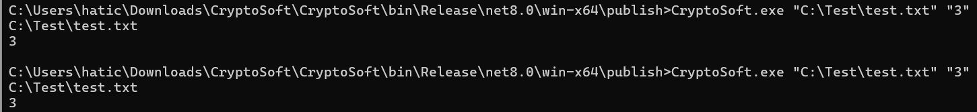

**To run CryptoSoft from a console interface:**



Follow the instructions from the console using CryptoSoft.exe!

**To run CryptoSoft from a graphical interface:**

CryptoSoft-only can also be used via the graphical user interface just by executing the .exe in this zip file; or from the console interface from the documentation above:



Very easy to use, all marked “highly interactive”!

**6. Compiling a console or graphical application**

If you wish to create an executable:

1. Open the command prompt in the project folder

2. Execute the command:

The CryptoSoft.exe executable can be found in bin/Release/net8.0/win-x64/publish/

**See higher up in the zips!**

**7. Troubleshooting and common errors**

**a) Error "File not found"**

**Solution**: Check that the file passed as a parameter exists.

**b) Error "Index out of range"**

**Solution**: Be sure to pass two arguments (file + key).

**c) Unreadable file after transformation**

**Solution**: The file has been encrypted with XOR, so run CryptoSoft again with the same key to decrypt it.

**d) DLL does not exist**

**Solution**: Check that it is referenced in the project (bin/Debug/net8.0/).

**8. Conclusion**

CryptoSoft is a simple, effective solution for encrypting and decrypting files using a minimalist XOR algorithm. Its DLL integration makes it easy to use within a C# project, while its console application mode lets you run it independently.